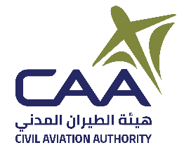
Air Navigation Safety Department (ANSD)

Form 171-2 Application for Flight Inspection Service Provider
Documentation Checklist
Date (yyyy/mm/dd) →
Indicate if you are applying for Initial or Renewal Certificate
Initial: ☐ | Renewal: ☐ | If renewal, previous  expire date (yyyy/mm/dd):
Checklist of Required Documentation for Initial Certificate
Form 171-2 and Form 171-3 |  |  | ☐
Proof of application fee payment* |  |  | ☐
Letter of Request from the service provider's Chief Executive to DGCAR |  |  | ☐
Applicant's Manual of Operations |  |  | ☐
Other documents as may be requested by DGCAR |  |  | ☐
Checklist of Required Documentation for Renewal Certificate
Form 171-2 and Form 171-3 |  |  | ☐
Letter of Request from the service provider's Chief Executive to DGCAR |  |  | ☐
Other documents as may be requested by DGCAR |  |  | ☐
Applicant Remarks and/or Questions
* Application fee is non-refundable. Certification fee will be billed upon approval of application and prior to certificate issuance.

