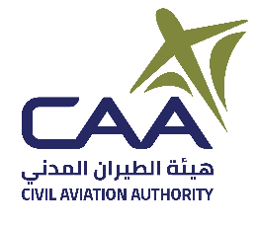
Air Navigation Safety Department (ANSD)

Form 179-0 Application for Aerodrome Flight Information Service Provider Certificate
Date (yyyy/mm/dd) →
Indicate if you are applying for Initial or Renewal Certificate
Initial: ☐ | Renewal: ☐ | If renewal, previous  expire date (yyyy/mm/dd):
List units and/or facilities to be included on certificate
(if needed for additional units/facilities, attach a continuation sheet)
Unit/Facility Name and Type |  | Unit/Facility Location

Checklist of Required Documentation for Initial Certificate
Form 179-0 | ☐
Proof of application fee payment* | ☐
Letter of Request from the service provider's Chief Executive to DGCAR | ☐
Safety Management System (SMS) | ☐
Airport Operations Manual | ☐
Other documents as may be requested by DGCAR | ☐
Checklist of Required Documentation for Renewal Certificate
Form 179-0 | ☐
Letter of Request from the service provider's Chief Executive to DGCAR | ☐
Other documents as may be requested by DGCAR | ☐
Applicant Remarks and/or Questions
* Application fee is non-refundable. Certification fee will be billed upon approval of application and prior to certificate issuance.

